Problem Statements

|  |  |
| --- | --- |
| **Date** | 28 SEPTEMBER 2022 |
| **Team ID** | PNT2022TMID27338 |
| **Project Name** | Project – Natural Disaster Intensity Analysis and Classification Using  Artificial Intelligence |
| **Maximum Marks** | 2 Marks |

# Customer Problem Statement Template:

Create a problem statement to understand your customer's point of view. The Customer Problem Statement template helps you focus on what matters to create experiences people will love.

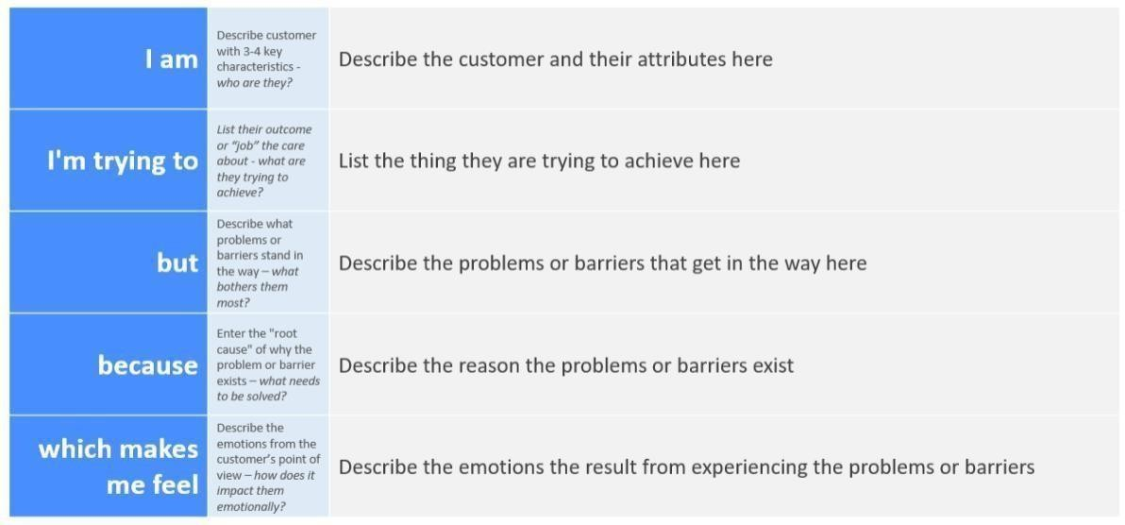

# Problem Statement for “Natural Disaster Intensity Analysis and Classification using Artificial Intelligence.”

## PROBLEM STATEMENT 1:

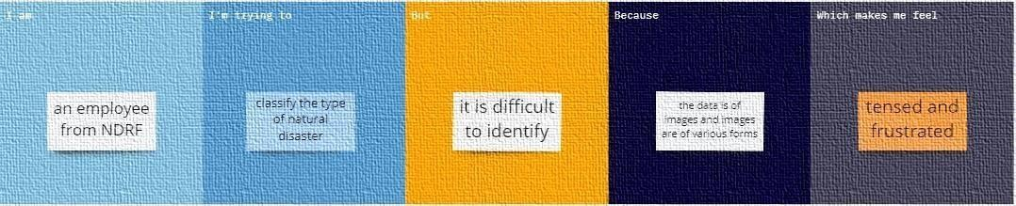

**PROBLEM STATEMENT 2:**

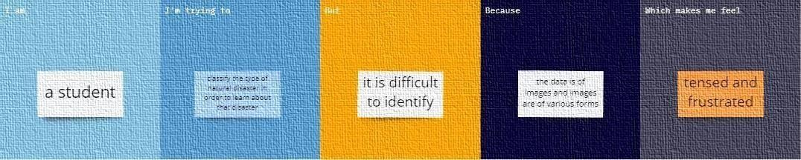

|  |  |  |  |  |  |
| --- | --- | --- | --- | --- | --- |
| **Problem**  **Statement (PS)** | **I am (Customer)** | **I’m trying to** | **But** | **Because** | **Which makes me feel** |
| Problem | An employee | Classify the | It is | The data is | Tensed and frustrated |
| Statement-1 | from NDRF | type of  natural | difficult  to | of images  and images |  |
|  |  | disaster | identify | are of |  |
|  |  |  |  | various |  |
|  |  |  |  | forms |  |
| Problem | A student | Classify the | It is | The data is | Tensed and frustrated |
| Statement-2 |  | type of  natural | difficult  to | of images  and images |  |
|  |  | disaster in | identify | are of |  |
|  |  | order to |  | various |  |
|  |  | learn about |  | forms |  |
|  |  | that disaster |  |  |  |

## Team Members:

**DHARUNRAJ PRANESH**

## SURYA PURUSHOTHAMAN